**Laboratory Assignment**

**On**

**Design Principles of Operating System**

**(CSE 3249)**

**Submitted by**

**Name : Dinanath Dash**

**Reg. No. : 2241004161**

**Semester : 5th**

**Branch : CSE**

**Section : 2241026**

**Session : 2024-2025**

**Admission Batch : 2022**



**DEPARTMENT OF COMPUTER SCIENCE & ENGINEERING**

**FACULTY OF ENGINEERING & TECHNOLOGY (ITER)**

**SIKSHA ‘O’ ANUSANDHAN DEEMED TO BE UNIVERSITY**

**BHUBANESWAR, ODISHA – 751030**

**Assignment 2: Familiarization with basic Commands in Unix Operating System and Shell Programming.**

**Objective of this Assignment:**

* To learn basic concepts of shell programming
* To lean concept of command line argument in shell script.

1. Write a shell script named as prog for merge the content of files a.txt, b.txt, and c.txt sort them and save the result in a file called result and display the sorted output on the screen. 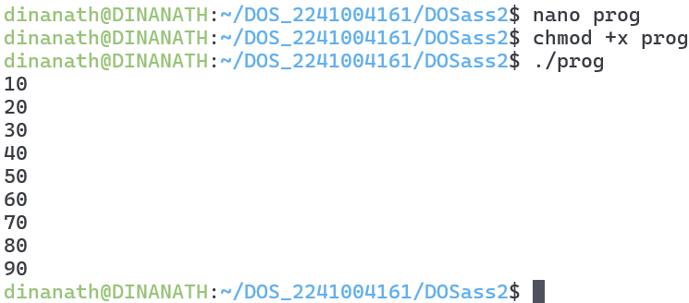
2. Write e a shell script named as systeminfo that will display the information about the login name of the user, name of the Unix system used by the user, type of the SHELL, Path of current working directory of the user and list of file contain in current working directory. 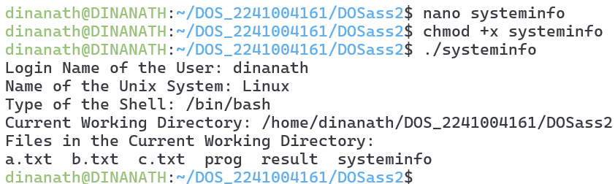
3. Write a shell script named as dtcal for displaying both the system date and calendar for specific month, say march 2022, in the given format: -

Date: specific date

calendar: current calendar. 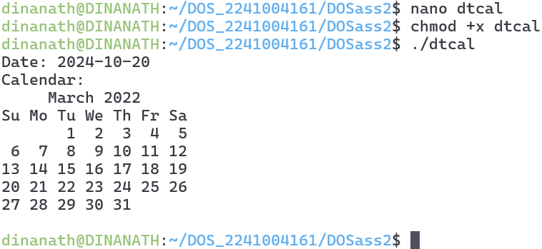

1. Write a shell script named as nvwc which will display the filename and linecount, wordcount and char count of the file dtcal in the following format:

Filename: dtcal

Line count: -

Word count: -

Charcout.

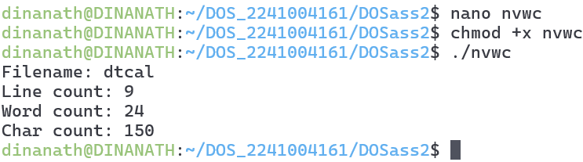

1. Write a shell script named as nvwc2 which will display the filename and linecount, word count and char count of any file given as argument to nvwc2 in the following format: filename linecount wordcount charcount file1 - - - 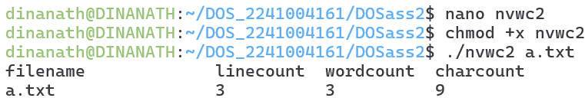
2. Write a shell script named as darg to display the total number of command line arguments along with the first two arguments. -Modify the script to display all the arguments. 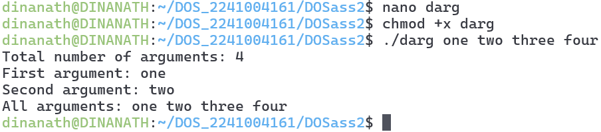
3. Write a shell script named as ndisp that will take three command line arguments specifying the value of n, m and a filename and display the first n number of lines and last m number of lines of the file given as argument. 